Assignment 9.3

**Creating two datasets:**

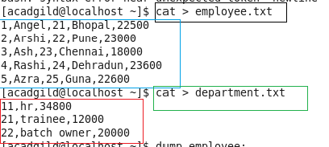

**Describing created datasets:**

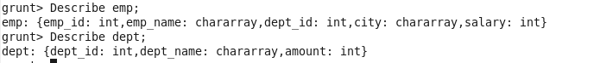

**Self-join** is used to join a table with itself as if the table were two relations, temporarily renaming at least one relation.

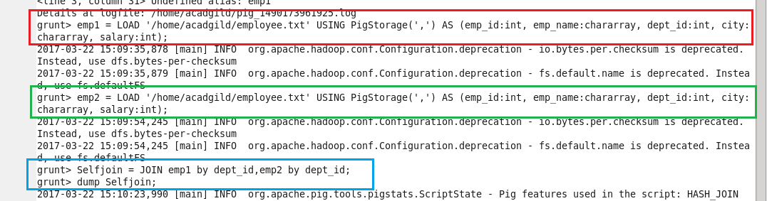

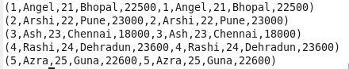

**Inner-Join**

An inner join returns rows when there is a match in both tables.

It creates a new relation by combining column values of two relations (say A and B) based upon the join-predicate. The query compares each row of A with each row of B to find all pairs of rows which satisfy the join-predicate. When the join-predicate is satisfied, the column values for each matched pair of rows of A and B are combined into a result row.

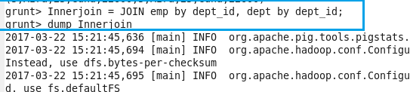

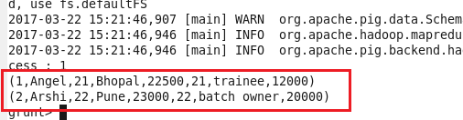

Left Outer Join

The **left outer Join** operation returns all rows from the left table, even if there are no matches in the right relation.

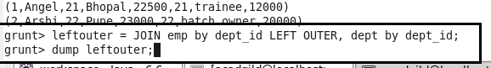

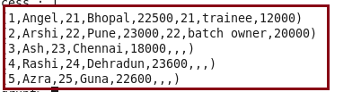

**Right Outer Join**

The **right outer join** operation returns all rows from the right table, even if there are no matches in the left table. It is jut opposite of left outer join.



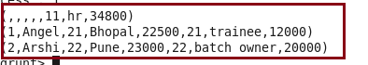

**Full Outer Join**

The full outer join operation returns rows when there is a match in one of the relations.



